CS-340-T5534 Client/Server Development 23EW5

8-1 Assignment - Data Aggregation Pipeline

Jacob Simmons, 25 June 2023

* **Create Database**



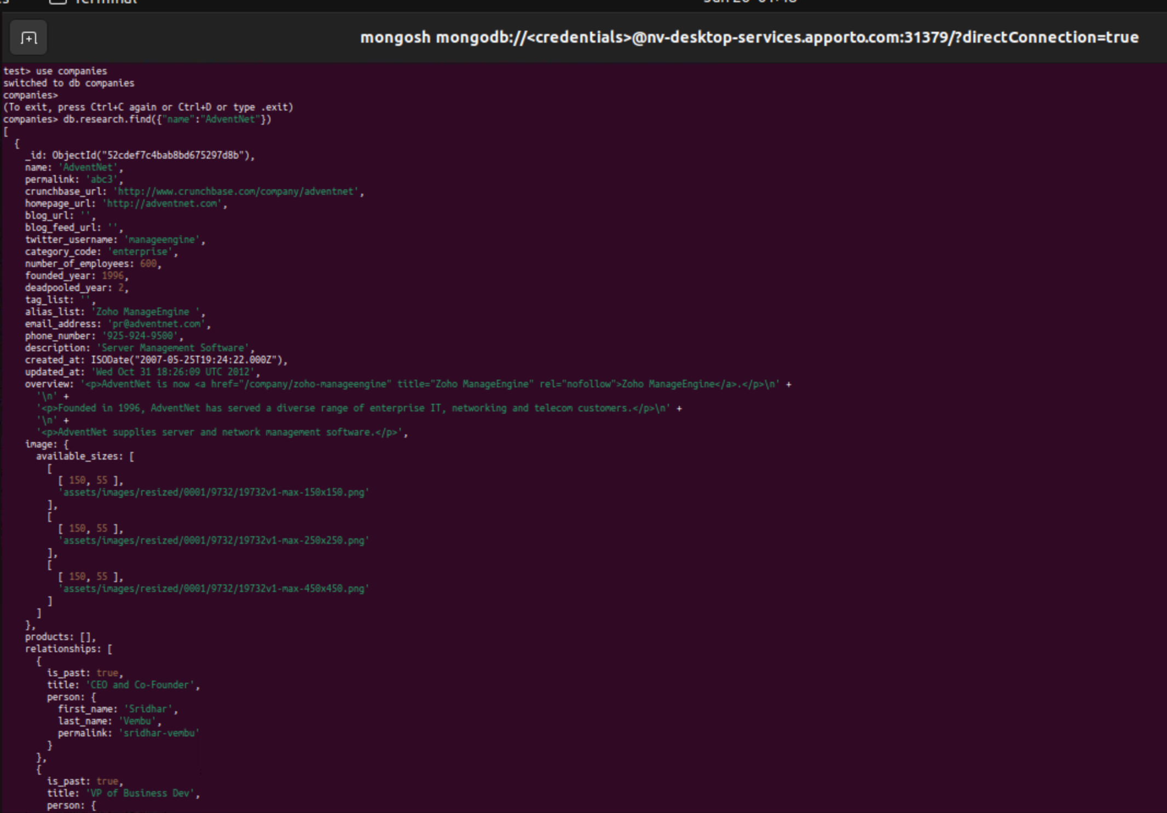

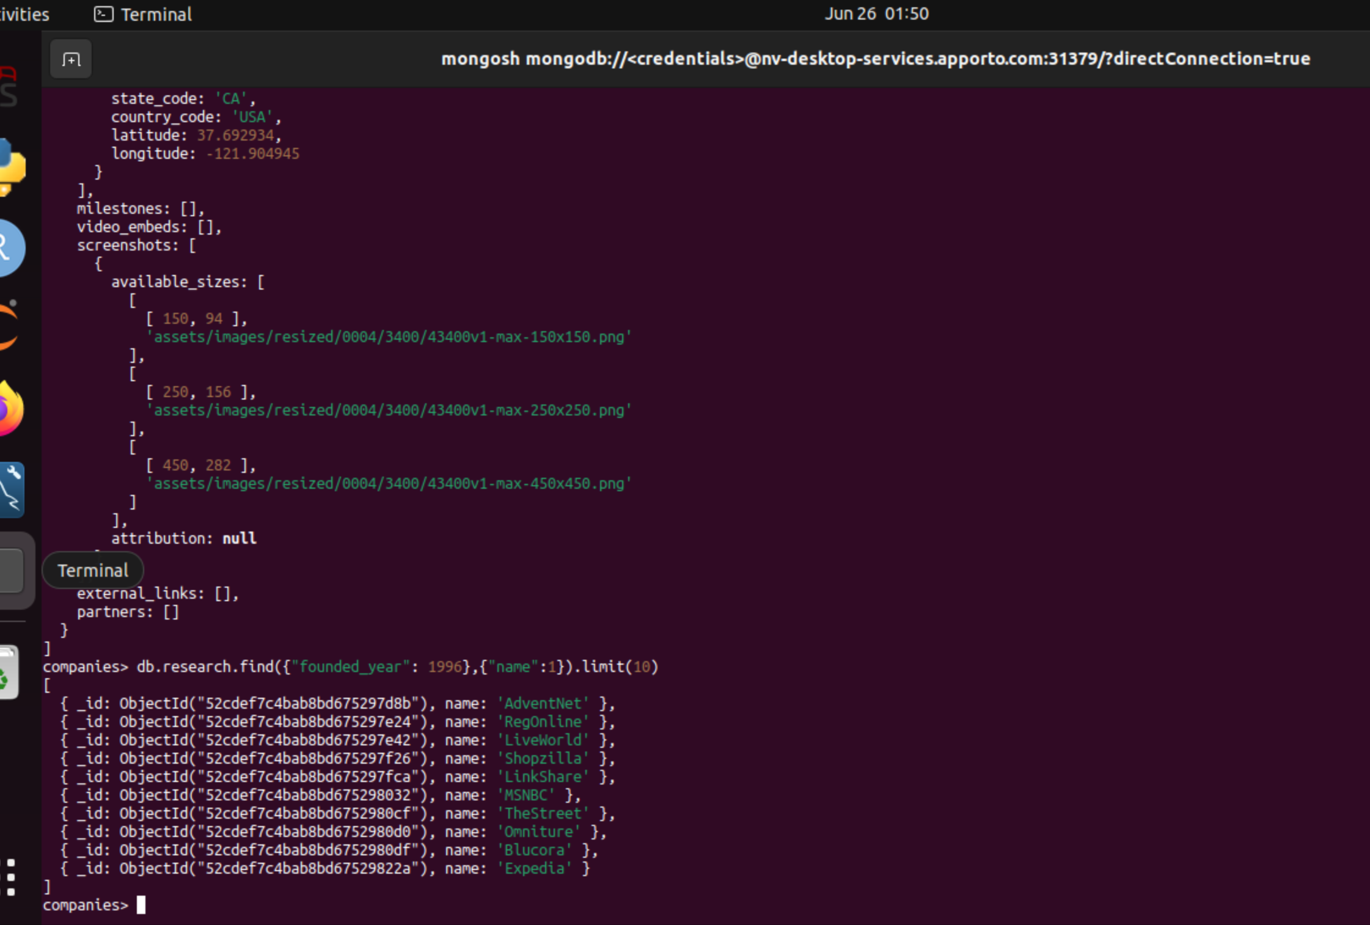

* **MongoDB Queries**

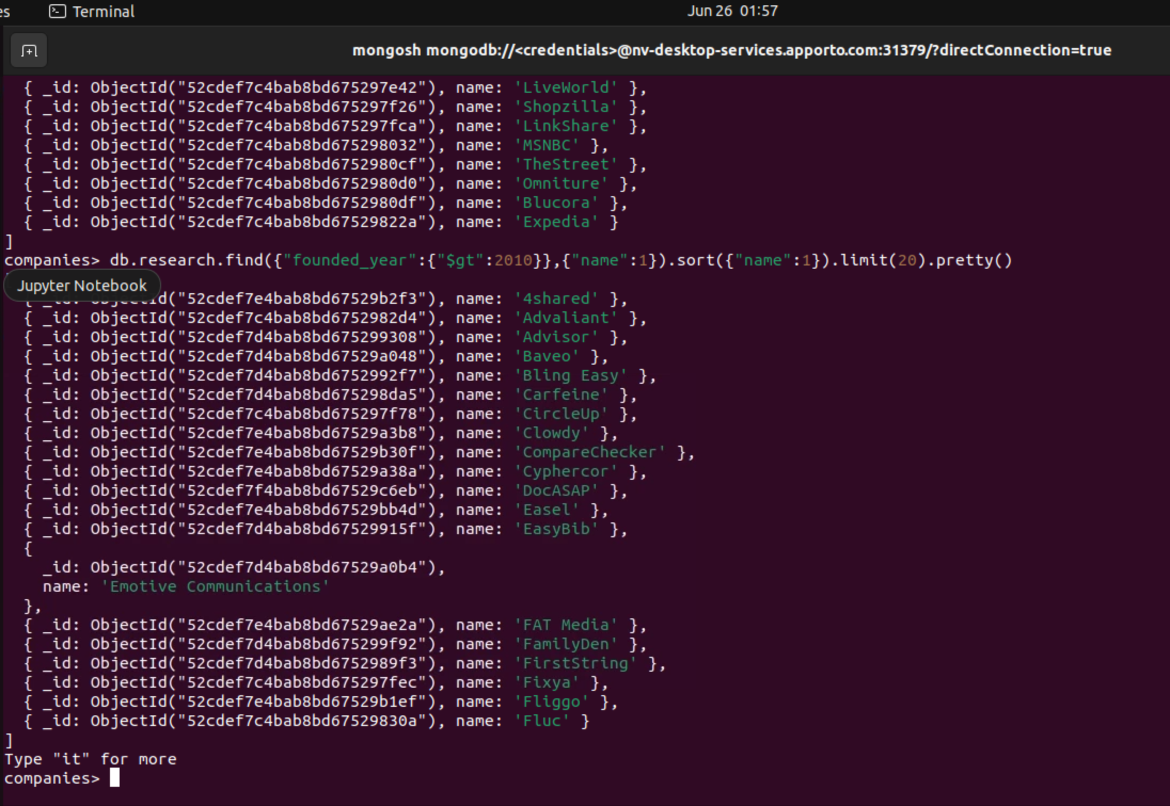

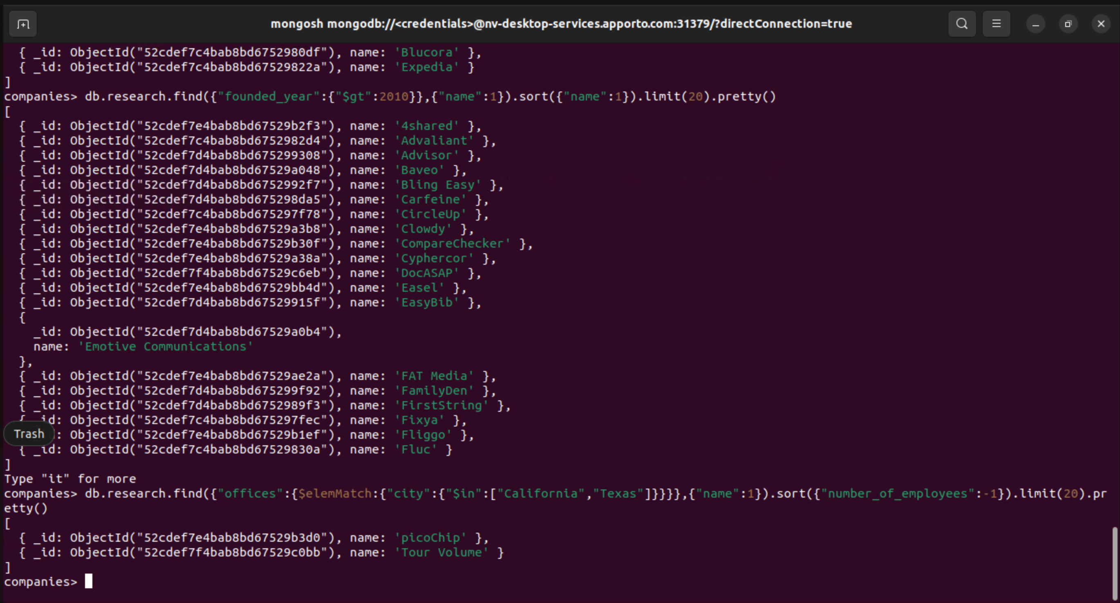

* **MongoDB Aggregation Pipeline**

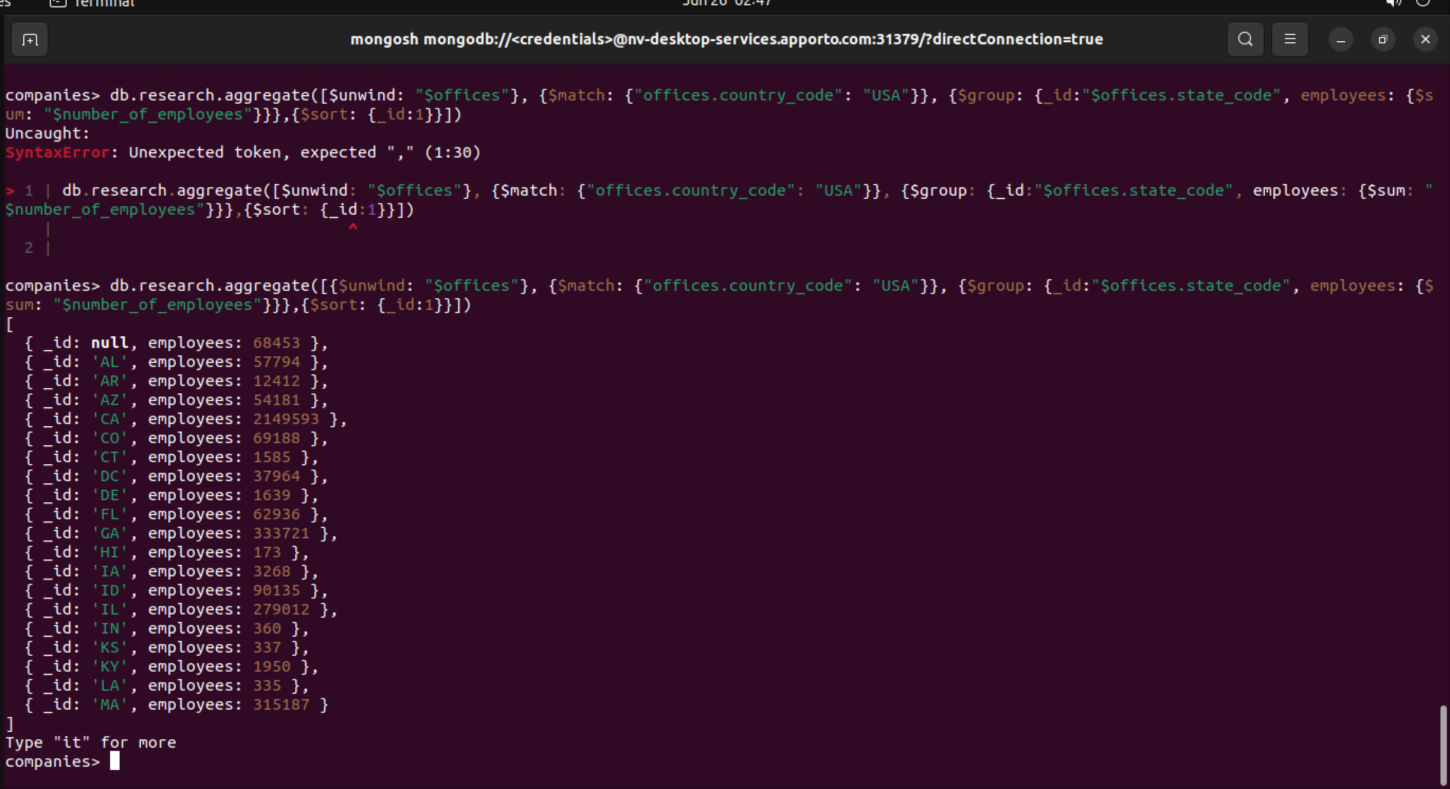

* **References**

None